Testing Diodes
Use the diode test feature of a DMM to test the P-N junction’s voltage drop. A good junction drops between 0.5V and 0.8V.
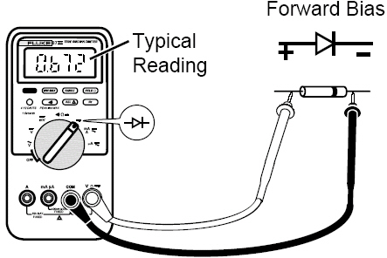
For forward bias readings, place the:
- Red test lead on the anode.
- Black test lead on the cathode.
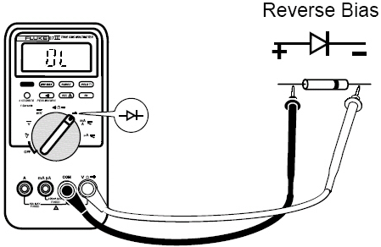
For reverse bias readings, place the:
- Black test lead on the anode.
- Red test lead on the cathode.

Diode Functioning Normally:
  - OL in one direction
  - Continuity in the other direction
Faulty Diode:
      - Continuity in both directions – shorted
      - OL in both directions – open
Diode Failures
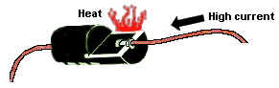
Excessive current and/or heat usually cause diode failures.

In a circuit, a good diode should still produce a forward-bias reading of 0.5V to 0.8V; however, the reverse bias reading can vary depending on the resistance of other pathways between the probes.

